EDU BRIDGE

A Project Report on

Student Management System

By

Batch: 2020-6524

Under the Guidance of

Chittaranjan Ghosh.

Technical Trainer

EduBridge

(School of coding)

## Introduction:

Student Management System manages student information in the with regard to maintain records It improves existing system. It has the facility of maintaining the details of the student, It will save time and energy which are spending in making reports and collecting data. Student Management System can be accessed throughout the admin with proper login provided.

. **Modules:-**

* Admin Module
* Staff Module
* Student Module

I have developed this Application in **Java and MySQL.**

The main objective of the Student management system is to maintain the records and update the details. It is difficult and time-consuming to collect all the details from each student. In Admin module, admin can add the details and update in the specific student . He can also view the total number of users at present of system. Admin can only see the admin page and cart if he wants to update something.

* It manages the details of student records.
* Saves the time of staff officer and faculties.
* This system makes student information more secure.

**Admin Module**: Admin can able to handle staff portal and student portal. It provides access to the staff for uploading new jobs as well as to track the process of job application with admin_id and password.

**Staff Module**: Staff can access this website by signing up. Staff can post jobs for student from his portal as well as he/she can update job portal for student

**Student Module**: Students can register the details and then logout

**Software Requirements:**

**Front end:** Java

**Back end**: MySQL workbench 8.0 CE.

**Operating System:** Window

# **Data Dictionary:**

Create a database Staff Registration

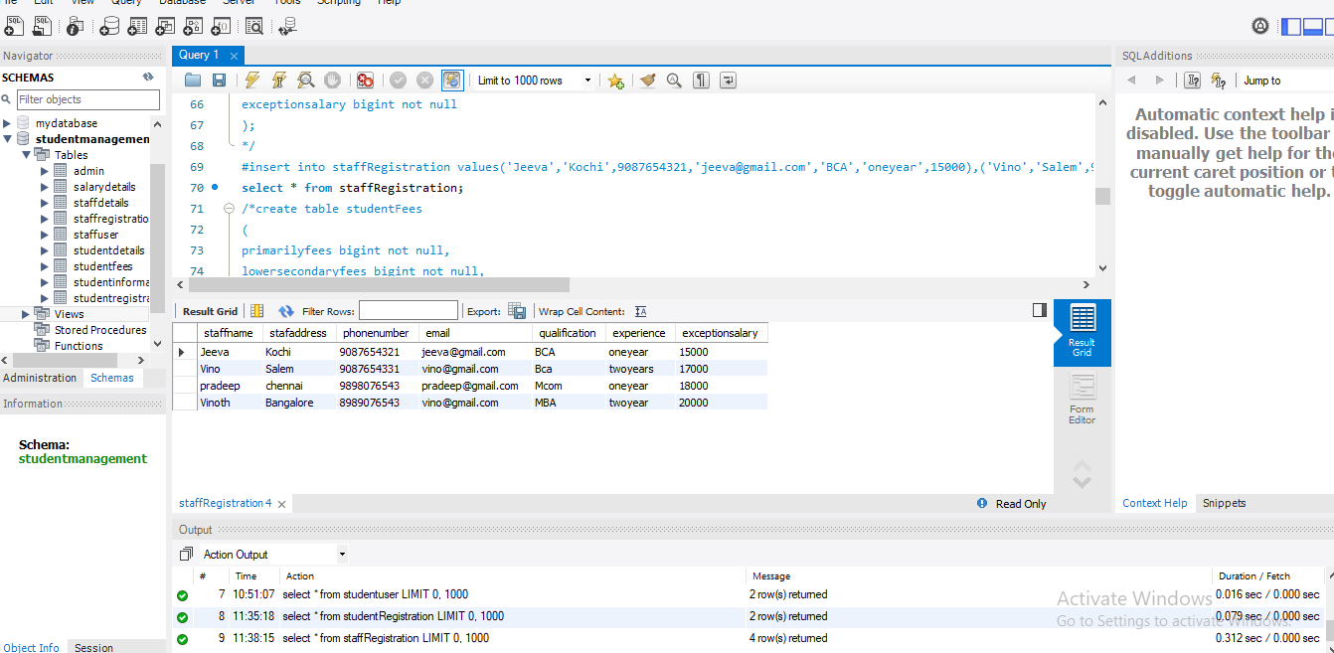

Create a database StudentRegistartion

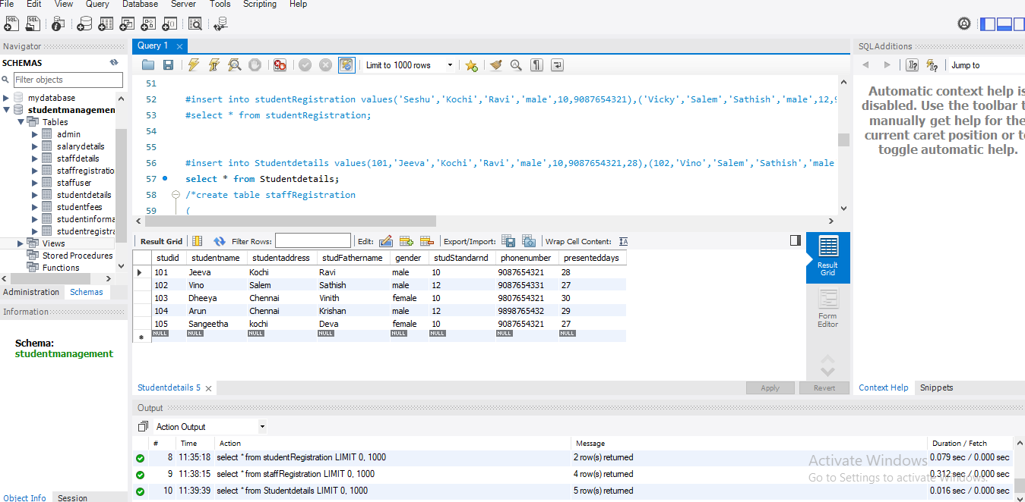

Create a database studentFees:

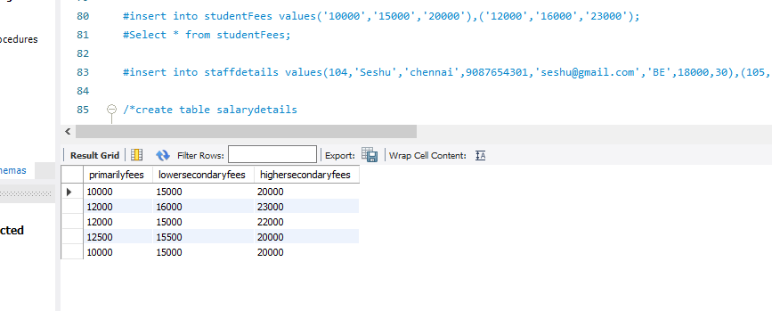

Admin Process

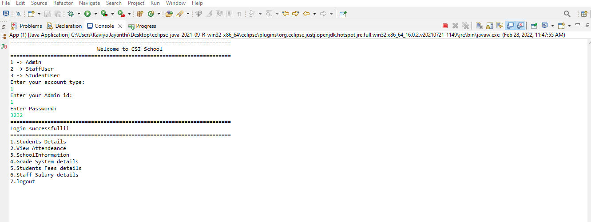

Students details:

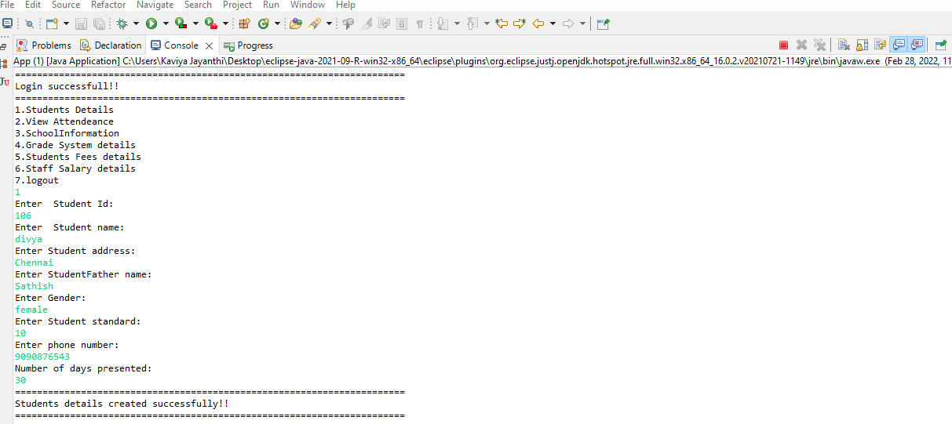

School information: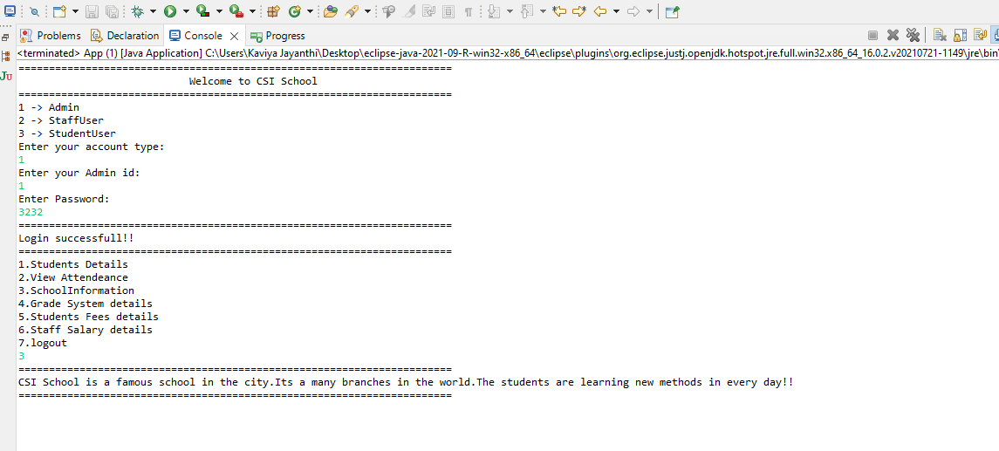

StaffRegistration

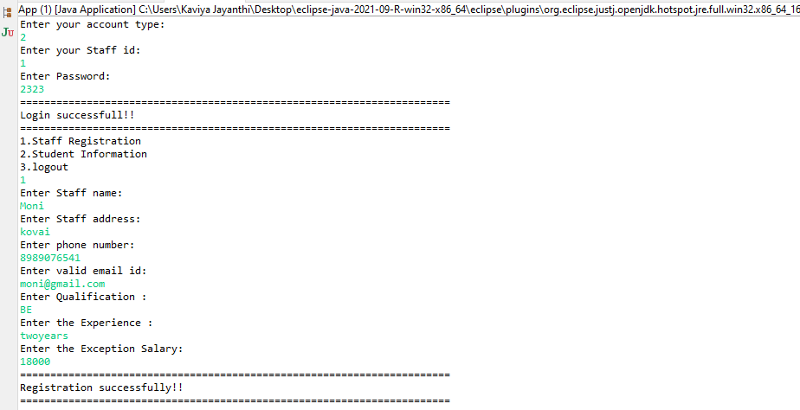

Student Information:

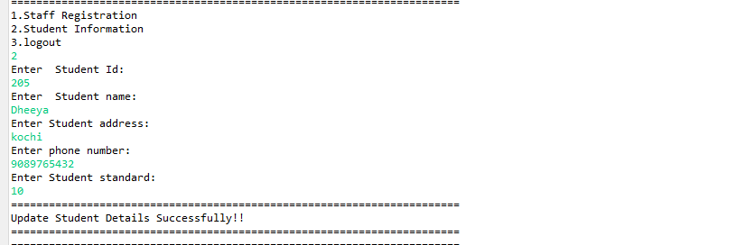

Grade System:

